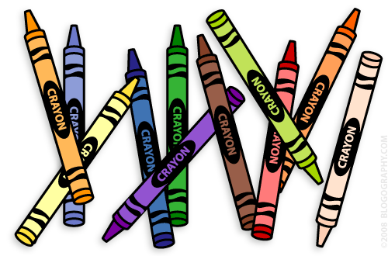**Our 1st Grade Classroom News**

**The Week of May 1st – 5th**

**Email:** [**Lweeks@bluevalleyk12.org**](mailto:Lweeks@bluevalleyk12.org)

**Website:** [**www.bluevalleyk12.org/hes/lweeks**](http://www.bluevalleyk12.org/hes/lweeks)

**Important Info**

**Upcoming Events**

* We will be working on abbreviations and plural words this week!

- There will be no reading log for the month of May.

-We could use some more dry erase markers if anyone is able to donate some!

-On May 11th, we will be celebrating 1st grade writing projects that we have completed all year long! Come join us in the gym from 2:45-3:15 to listen to 1st graders read their stories they wrote! Students will go around to random adults and read their stories during this time. For every child that reads to you, you will hand them a star to put on a chart!

**May 1st** Reading charts due

**May 4th** Amigo Day

Mrs. Weeks gone all day for a meeting

**May 5th** Field Day 9-11am

**May 11th** 1st Grade Author’s Day @2:45 in Gym

**May 19th** ½ Day of School

Last Day of School!!!!

**Challenges of the Week**

**Math Challenge of the Week:** Have your child solve hard problems using a calculator. Here are example problems they can solve:

499 + 867 = ? 1,546 – 1,200 = ?

120 x 45 = ? 625 / 5 = ?

**Reading Challenge of the Week:** Have your child read a book about school. It can be any book with a school involved (fiction or nonfiction). Then have them write down self-to-text connections they make with the book as they read. How can what they are reading relate to their own experiences at school?

**Writing Challenge of the Week:** Have your child write about all of the things they are excited about for 2nd grade! We recently had 2nd graders come into our classroom to explain what happens in 2nd grade so they should have an idea of what to expect!

**Tech of the Week**

[**2nd Grade Websites**](https://askatechteacher.wordpress.com/great-websites-for-kids/2nd-grade/) – It’s time to start thinking about websites for your almost SECOND GRADER! ☺ This website has some awesome websites your child can use over the summer!

<https://askatechteacher.wordpress.com/great-websites-for-kids/2nd-grade/>

[**How to Draw**](https://itunes.apple.com/us/app/how-to-draw-step-by-step-drawing/id422572351?mt=8) is a great app. The kids LOVED learning how to draw pictures last week. This is a great way to teach them how to follow directions.